Day 9 - 28th July 2026

Spring Framework - Quick revise

Task 1:

Can you create a Maven based spring project using ide.. To print a welcome..note
9.04 to 9.08

Task 2:

Now create a POJO class for student so that can be managed as a spring bean
9.09 to 9.14

Task 3:
Configure the above Student bean in the bean-factory-demo.xml file.
That means you need to configure the Student bean in the XML file so the BeanFactory knows how to create it.
And create a main class and run it.. A pictorial rep of the scenario is given below
9.15 to 9.20
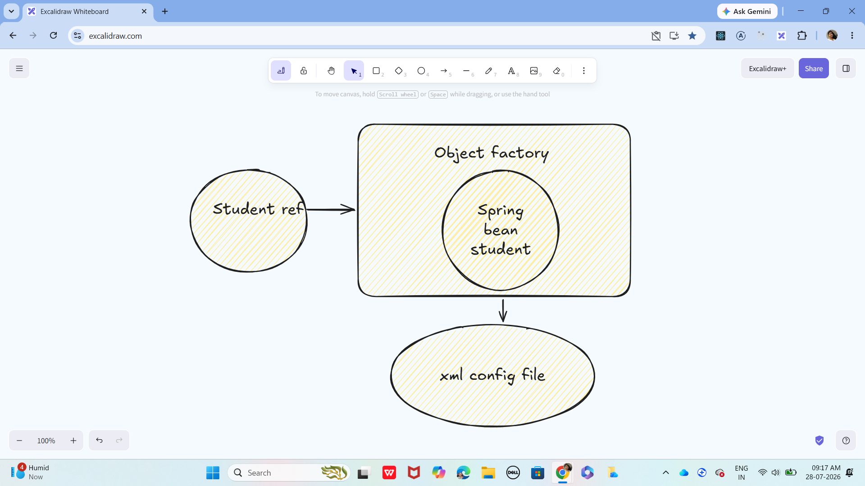

Task 4:
Can you explain application context with the syntax..
9.21 to 9.23

Task 5:
Why use application context .. plz list some uses?
9.24 to 9.27

Task 6:
What are features of Spring Framework .. list them with 1 or 2 lines explanation?
9.28 to 9.31

Task 7:
Why do you thunk w e use spring framework.. Advantages list them down?
9.32 to 9.35

Task 8:
What do you understand by IOC? Explain with diagram..
9.36 to 9.40

Task 9:
How many types of IOC do you have in spring?
What are they with explanation
9.41 to 9.47

Task 10:
What is DI in spring?
9.48 to 9.52

Task 11:
How many types of DI do we have?
Explain
9.53 to 9.56

Task 12:
What is Spring Application Configuration?
9.57 to 10.00

Task 13:
What are the different ways to configure spring applications?
10.01 to 10.04

Task 14:
Why we need spring application configuration?
10.05 to 10.08

Task 15:
What are the different ways to configure spring applications? Same as 13th
10.09 to 10.12

10.45 to 11 break

Task 16:
What is bean scope .. give different scopes with description
10.13 to 10.15

Task 17:
What is autowiring in spring?
10.16 to 10.18

Task 18:
What are diff ways of autowiring?
10.19 to 10.21

Task 19:
What is diff between a normal java object and Spring bean?
10.22 to 10.25

Task 20:
What is diff between @ component and @ bean
10.25 to 10.27

Task 21:
A different way to create an application using
https://start.spring.io/ try it .. and let me know what is it?
10.28 to 10.31

Task 22:
Using Spring initialiser create an employee class , appcofig file, and main class and see how it works
10.32 to 10.35
Note: In real applications, Spring Boot creates it automatically using SpringApplication.run()
Task 23:
We have spring annotations:
Like
@bean
@controller
@value
@conponentScan
@configuration
@service
@repository
@Qualifier
@required
@component
@autowired
@scope

Can you give a liner about these
10.37 to10.48

11 to 11.10 … plz complete above tasks…

Spring Boot:

=============================================================================
SpringBoot
=============================================================================
Demo on Spring Boot REST API:
@SpringBootApplication
public class Myapp{

public static void main(String[] args){

// here Tomcat which is embedded in spring boot runs automatically
SpringApplication.run(Myapp.class, args);
}
}

import org.springframework.stereotype.Controller;
import org.springframework.web.bind.annotation.RequestMapping;
import org.springframework.web.bind.annotation.RestController;

@RestController
@RequestMapping("/api/usersApi")
public class MyController{

private List<String> users = List.of("Prasunamba", "Meher", "Kom");

@GetMapping
public List<String> getUsers(){

// this is returning JSON response
return users;
}
}

<!-- Source: https://mvnrepository.com/artifact/org.springframework.boot/spring-boot-dependencies -->
<dependency>
<groupId>org.springframework.boot</groupId>
<artifactId>spring-boot-dependencies</artifactId>
<version>4.1.0</version>
<type>pom</type>
<scope>import</scope>
</dependency>

===================================================================

Connecting to db

Plz install
My sql or sql

3.05 to 3.10

Create a MySql/Sql database ( customerDB).
Create a table (CustomerInfo).
Insert a few records..
Verify data using MySQL Workbench or CLI.

Here is your DAO

import java.sql.*;

public class CustomerDAO {

private String driver;
private String url;
private String userName;
private String password;

// Setter methods for dependency injection
public void setDriver(String driver) {
this.driver = driver;
}
public void setUrl(String url) {
this.url = url;
}
public void setUserName(String userName) {
this.userName = userName;
}
public void setPassword(String password) {
this.password = password;
}

// fetch customer records
public void selectAllRows() throws ClassNotFoundException, SQLException {
System.out.println("Retrieving customer data..");

// driver is loading
Class.forName(driver);

// connection establishment is done here
Connection con = DriverManager.getConnection(url, userName, password);

// Executing our query
Statement stmt = con.createStatement();
ResultSet rs = stmt.executeQuery("SELECT * FROM CustomerDb.CustomerInfo");

while (rs.next()) {
int customerId = rs.getInt(1);
String customerName = rs.getString(2);
double customerFees = rs.getDouble(3);
String custAddress = rs.getString(4);

System.out.println(customerId + " " + customerName + " " + customerFees + " " + custAddress );
}

// Close connection
con.close();
}
}

Spring Configuration (beans.xml):
<?xml version="1.0" encoding="UTF-8"?>
<beans xmlns="http://www.springframework.org/schema/beans/"
xmlns:xsi="https://www.w3.org/2001/XMLSchema-instance"
xsi:schemaLocation="http://www.springframework.org/schema/beans/
https://www.springframework.org/schema/beans/spring-beans.xsd">

<bean id="customerDAO" class="CustomerDAO">
<property name="driver" value="com.mysql.cj.jdbc.Driver"/>
<property name="url" value="jdbc:mysql://localhost:3306/cusytomerdb"/>
<property name="userName" value="root"/>
<property name="password" value="pwd"/>
</bean>

</beans>

public class Main {
public static void main(String[] args) throws SQLException, ClassNotFoundException {

ApplicationContext context = new ClassPathXmlApplicationContext("beans.xml");

// Retrieve bean
CustomerDAO customerDAO = context.getBean("customerDAO", CustomerDAO.class);

// Call method to fetch cust records
customerDAO.selectAllRows();
}
}

Task 24:

What are the features of springboot?
4 to 4.05

Task 25:
What are the advantages of Spring boot?
4.06 to 4.010

Task 26:
What are the key components of Spring boot?
4.11 to 4.15

Task 27:
Why spring boot over spring?
4.16 to 4.20

Task 28:
Can you explain the internal working of spring boot?
4.21 to 4.25

Task 29:
List out the starter dependencies for spring boot
4.26 to 4.30

Task 30:
import org.springframework.boot.SpringApplication;
import org.springframework.boot.autoconfigure.SpringBootApplication;
@SpringBootApplication
public class MyApplication
{
public static void main(String[] args) {
SpringApplication.run(MyApplication.class, args);
}
}
In this above code ..
What is the internal working of above code ..
Give thhe step by step explanation

4.31 to 4.35

Task 31:
What is the syntax to change the port of the embedded Tomcat server in Spring Boot?
4.36 to 4.40

